|  |  |
| --- | --- |
| ENGR 325 Lab 3  Interfacing with UART Devices.  23rd Sept 2019.  Prof Randal Brouwer | Abstract  This lab focused on working with serial communication devices (UARTs), generating a complex system using the Qsys tool, using the Signal Tap Logic Analyzer tool, and writing C language programs for the NIOS processor system using function calls provided by the Hardware Abstraction Layer (HAL) (or device drivers).  Daniel Ackuaku |

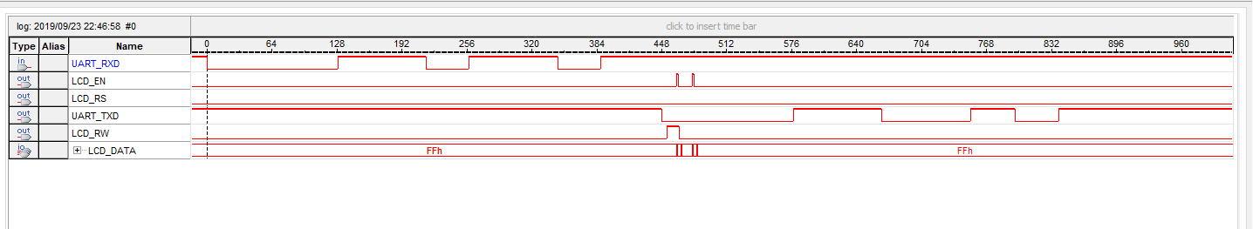 Part 1:

#include "altera_up_avalon_character_lcd.h"

#include "altera_up_avalon_rs232.h"

int main(void)

{

// declaration of global vairables for the LCD and Serial

alt_up_character_lcd_dev * char_lcd_dev;

alt_up_rs232_dev* Serial;

// open the Character LCD port

char_lcd_dev = alt_up_character_lcd_open_dev ("/dev/LCD");

/* Initialize the character display */

alt_up_character_lcd_init (char_lcd_dev);

/* Write "the DE2 board" in the second row */

char dummy[] = "\0"; // temporailiy houses characters that make up username

char username[] = "Daniel"; // hardcoded username

char user_input[16];

char password[] = "qwerty1234";

char user_pass[16];

//alt_up_character_lcd_string(char_lcd_dev, dummy);

/* Open the Serial connection */

Serial = alt_up_rs232_open_dev ("/dev/Serial");

/* Declaraiotion of variables needed to read and write data to LCD and PuTTy */

alt_u8 rs232_r_data; // character array in memory to house read data

alt_u8 *rs232_r_ptr = &rs232_r_data; // pointer to address of read character array

alt_u8 rs232_w_data1; // character array in memory to house write data

alt_u8 *rs232_w_ptr = &rs232_w_data1; // pointer to address if write character array

alt_u8 rs232_w_data2; // character array in memory to house write data

alt_u8 *rs232_w_ptr2 = &rs232_w_data2; // pointer to address if write character array

alt_u8 *parity_error; // parity_error pointer for read funciton

alt_up_rs232_read_data( Serial, rs232_r_ptr, parity_error);

int login_size = 15;

int password_size = 15;

int i = 0;

/* The while loop runs continually the amin loop that houses the rest of the functions */

while(1) {

/* Write "Username :" in the first row */

alt_up_character_lcd_init (char_lcd_dev); // clears the display

alt_up_character_lcd_string(char_lcd_dev, "Enter login :");

alt_up_character_lcd_set_cursor_pos(char_lcd_dev, 0, 1); //moves cursor to the 2nd row

while (rs232_r_data != "\r" && i < login_size){

if ( alt_up_rs232_read_data( Serial, rs232_r_ptr, parity_error) == 0) {

dummy[0] = rs232_r_data;

rs232_w_data1 = rs232_r_data; // data written to PuTTy

alt_up_rs232_write_data(Serial, rs232_w_data1); // output char to PuTTy

alt_up_character_lcd_string(char_lcd_dev , dummy);

user_input[i] = dummy[0];

i++;

dummy[0] = "\0";

}

if (rs232_r_data == '\r') {

i = 0;

break;

}

}

//Prompts the user to continue

alt_up_character_lcd_init (char_lcd_dev); // clears the display

alt_up_character_lcd_string(char_lcd_dev , "Login received \0");

alt_up_character_lcd_init (char_lcd_dev); // clears the display

alt_up_character_lcd_string(char_lcd_dev , "Enter password : ");

alt_up_character_lcd_set_cursor_pos(char_lcd_dev, 0, 1);

while (rs232_r_data != "\r" && i < login_size){

if ( alt_up_rs232_read_data( Serial, rs232_r_ptr, parity_error) == 0) { // if a read was successfull

dummy[0] = rs232_r_data;

rs232_w_data2 = rs232_r_data; // data written to PuTTy

alt_up_rs232_write_data(Serial, rs232_w_data2); // output char to PuTTy

alt_up_character_lcd_string(char_lcd_dev , "*");

user_pass[i] = dummy[0];

i++;

dummy[0] = "\0";

}

if (rs232_r_data == '\r') {

i = 0;

break;

}

}

if (username[i] == user_input[i] && password[i] == user_pass[i] ) {

alt_up_character_lcd_init (char_lcd_dev); // clears the display

alt_up_character_lcd_string(char_lcd_dev , "Login Succesful: ");

alt_up_character_lcd_set_cursor_pos(char_lcd_dev, 0, 1);

alt_up_character_lcd_string(char_lcd_dev , "Welcome");

return 0;

}

else {

int y = 0;

alt_up_character_lcd_init (char_lcd_dev); // clears the display

alt_up_character_lcd_string(char_lcd_dev , "Attempt failed :(.. ");

alt_up_character_lcd_set_cursor_pos(char_lcd_dev, 0, 1);

alt_up_character_lcd_string(char_lcd_dev , "Try again");

for (y = 0; y < 40000 ; y++) {

alt_up_character_lcd_cursor_off(char_lcd_dev);

alt_up_character_lcd_cursor_blink_on(char_lcd_dev);

}

y = 0;

}

if (i = 0) {

alt_up_character_lcd_init (char_lcd_dev); // clears the display

break;

}

}

}